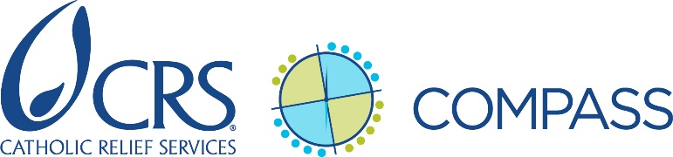

Donor Visit/Meeting Planning Checklist

INstRUCTIONS: This checklist is intended to help the project manager keep track of key donor field visit planning activities. Adapt for use in preparing for donor meetings (see items indicated with an asterisk*). Add or delete items based on the specifics of the donor visit (or meeting) you are planning. Use this checklist to review the status of planning actions with others involved in preparing for the donor visit or meeting.

Site visit plan And Preparation for Specific Sessions DURING THE VISIT
☐ | Initial site visit plan drafted and reviewed by senior management team and HQ donor engagement staff, if applicable
☐ | Revised draft of site visit plan shared with donor for review and comment
☐ | Second draft of site visit plan shared with donor after incorporating donor feedback
☐ | “Dry run” of site visit plan completed (if needed) and any adjustments made based on CRS and partner observations
☐ | *Final site visit plan (or meeting plan) shared with donor, partner(s) and CRS team
☐ | *Guidance shared with partners on any presentations they or communities should prepare for the donor field visit (or donor meeting)
☐ | *Guidance shared with CRS staff on any presentations or materials needed for the donor visit

Visit LogisticS and Financial Issues
☐ | Vehicle(s) and driver(s) arranged for donor airport and hotel transfers (if necessary)
☐ | Vehicle(s) and driver(s) arranged for CRS and donor travel to site visit location(s)
☐ | Any internal flights booked for CRS and donor staff (if needed)
☐ | Hotel arrangements confirmed for CRS, donor, and (as needed) partner representatives at site visit location(s)
☐ | Hotel arrangements confirmed for donor representatives for arrival/departure and CRS office meetings (if needed)
☐ | *Arrangements finalized for any meals/events to be organized at CRS’ office/in the city
☐ | Arrangements finalized for any meals/events to be organized at partner location
☐ | Final donor arrival/departure information provided to CRS operations staff (if applicable)
☐ | Translation services arranged for donor (if necessary)
☐ | Payment arrangements for donor clarified before visit (donor to pay directly; CRS or partner to pay, donor to reimburse, etc.)
☐ | Estimated costs associated with the site visit (hotel, meals, transport, translation) included in CRS and partner cash forecasts
☐ | Cash advance requests/pre-payments or other means of covering field visit costs prepared and processed

INformation for donor: Background on CRS, Partner(s), and Country (Donor Visit Packet) – *also relevant for donor meetings
☐ | Background information on CRS’ history and programming in country prepared for donor (if needed)
☐ | Background information on partner(s), including history and programming in their area of operations, prepared for donor (if needed)
☐ | Brief bios/profiles of key CRS and partner staff prepared
☐ | Country visitor information (e.g. Visitor Guide including visa requirements, health, weather, packing, and security information, Constant Companion) prepared for donor (if needed)
☐ | Any updated project information requested by donor prepared for inclusion in donor visit packet
☐ | Draft of donor visit packet incorporating all relevant information above reviewed by country program senior management and HQ donor engagement staff as applicable
☐ | Final donor visit (or meeting) packet/donor briefing book sent to donor
☐ | Pre-visit review completed with donor to answer any final questions (per donor interest)

Information for CRS and PARtner(s): Background on Donor, Visit Talking Points/Key Messages (CRS Briefing DOCUMENT) - *also relevant for donor meetings
☐ | Background information on donor (geographic and programmatic funding priorities, leadership, resources, strategies, “hot-button issues”, etc.) prepared for CRS stakeholder review
☐ | Brief bios/profiles of donor visit delegation obtained from donor or otherwise prepared for CRS and partner review
☐ | Brief summary of the donor’s history with CRS and relationship vis à vis the project prepared
☐ | Current general donor engagement strategy (or relevant extracts) obtained from IDEA (for centrally-managed donor relationships)
☐ | Project executive summary and summary of latest project progress report prepared for CRS stakeholders less familiar with the project
☐ | CRS talking points and key messages for the visit/meeting drafted for country program senior management review (and HQ donor engagement staff review as applicable)
☐ | CRS talking points and key messages for the visit/meeting finalized
☐ | Briefing document prepared for CRS incorporating all of the above points and shared with CRS staff who will participate in the donor visit/meeting
☐ | Preparatory briefing held with all CRS staff who will participate in the donor visit/meeting
☐ | Pre-donor visit/meeting briefing materials shared with partner(s) and briefing held with all partner staff who will participate in the donor visit/meeting

