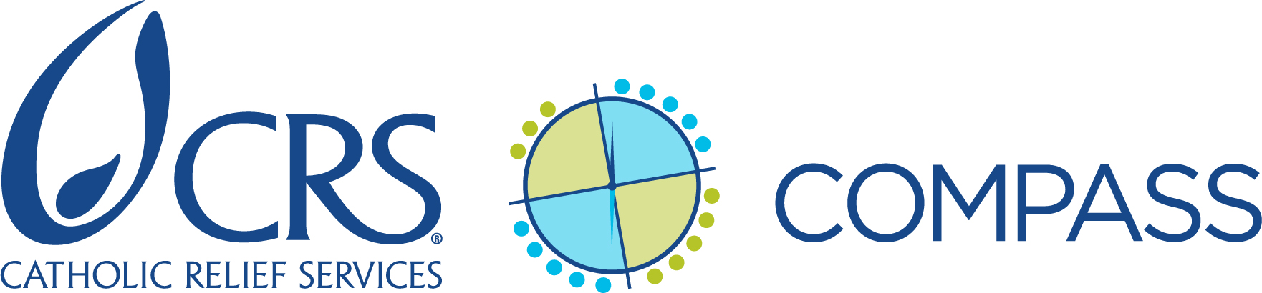

Reflection Questions for Developing a Project Start-up Staffing Plan

Instructions: During project design, after the project activities schedule and project staffing structure are well-defined, the proposal decision-maker convenes a meeting of individuals best suited to help think through the needs of the project start-up staffing plan. This could include members of the senior management team (SMT) along with the proposal human resources lead, country program HR manager (if the HR manager is not the proposal HR lead), head of programming (HoP) and head of operations (HoOps), partner leadership, and the proposal technical lead.

Use the questions below as prompts; add questions and discuss other issues as relevant to the project. Refer to the responses to the Donor Reality Checklist when considering start-up staffing needs related to externally-funded projects. Keep in mind that for external funding opportunities, it’s important to think through start-up staffing requirements for both pre-award and post-award start-up activities.

Start-up staffing discussions may lead to some revisions to the project staffing and/or recruitment plan (see Standard 4, key actions 1 and 3 on compass.crs.org) and possibly the project budget and activities schedule.

Finally, don’t forget that after defining a start-up staffing plan, you must develop an accompanying budget for any costs that cannot be accommodated in the project budget or that CRS may incur pre-award.

- Donor requirements and preferences (externally funded projects only)

- Are anticipated or known project donor requirements particularly complex and/or new to the country program/project team? If so, is additional or specialized finance or operations staffing needed to set up project systems to meet donor requirements?

- What other donor requirements and preferences will affect start-up and how CRS should staff it? For example:
  - Does the donor require or prefer a high level of communication from CRS in the start-up phase? Who needs to be involved in this communication?
  - Is the donor likely to require significant involvement in reviewing and approving project plans, systems or start-up deliverables?
  - Does the donor have any unusual pre-award requirements or negotiation processes that will require significant staff time, especially time from field staff?

- Project operations requirements (including recruitment)

- Does the project require setting up a sub-office or establishing a new space for the project team? If so:
  - What operations support is needed to do this?
  - Can the existing operations team provide such support in the required timeframe, keeping in mind ongoing commitments and responsibilities, and the logistics associated with the start-up (e.g., remote sub-office location; permissions needed, etc.)? Regional or temporary duty (TDY) support is more appropriate than a consultant or temporary local staff.

- Does the project include significant and/or complex supply chain management components, whether for CRS or beneficiary use (e.g. large procurement of IT equipment; complex procurement/transportation of items for end-use by project beneficiaries)? If so:
  - How intensive are the set-up requirements for this?
  - Is specialized expertise needed? If so, will permanent project staff bring that expertise and will they be in place from day one of project start-up? If not, who can provide this expertise?

- What are the project’s recruitment needs? Can existing HR staff manage the necessary recruitment processes in a manner that will facilitate timely project start-up, keeping in mind their ongoing responsibilities? (Note that existing HR staff cannot usually manage this extra recruiting, so consider TDY, consultant, or short-term/temporary hiring of local recruiters.) When answering this question, consider:
  - The size of the permanent project team
  - The number of positions to be recruited locally
  - The number of positions likely to be filled by staff new to CRS
  - The ease of finding staff with the required profiles, keeping in mind the labor market

- Given the response to question 5, how intensive are the HR needs likely to be in the early months of the project? Remember that in addition to recruitment, demands on HR will include finalization of the hiring process (contracts), and general onboarding. Keeping in mind other country program activities, is current HR staffing sufficient to manage project HR start-up, or is surge support needed?

C. Programming requirements

- Does the project include technical programming interventions or approaches that are entirely or largely new for the country program, the project team, and/or the partner team? If so:
  - What technical expertise or specialized skill set may be needed at start-up to ensure timely and quality start-up of programming activities and capacity strengthening of the project team?
  - Will permanent project staff bring that expertise or skill set, and if so, is it likely that those staff will be in place from day one of project start-up?

- Are other specialized skill sets needed to properly ground the project in the selected technical approach (e.g., curriculum development, TOTs, etc.)? If yes, have we already identified and confirmed the availability of staff and/or consultants who offer those skills?

- Does the project have any special MEAL requirements? If yes, will permanent project staff bring that expertise or skill set, and if so, is it likely that those staff will be in place from day one of project start-up?

D. Partnership and stakeholder relationship-building considerations

- What is each partner’s capacity to implement this project? Will any partners require substantial capacity strengthening and accompaniment in the first several months? If so, what kind of support may be needed, and who is best placed to provide it?

- What kinds of early start-up capacity assessments may be required? Pre- or post-award? For how many partners? Does the country program have the technical capacity and person-power to conduct these assessments given ongoing activities, or is surge support/additional technical expertise needed?

- Will this project require significant initial relationship-building by CRS with consortium members, community stakeholders and/or local, regional, or national government? If so:
- At what level must CRS build/strengthen relationships, and which CRS staff need to be involved?
- If intensive SMT involvement will be required in project start-up, is a coverage plan needed such as naming an acting HoP or bringing in surge support to cover SMT members’ typical duties?

- Are any aspects of project governance still to be finalized, such as with consortium members or new partners? Who should be involved in finalizing the project governance structure?

- Are there significant initial consortium or more complex partnership-related needs, such as planning a consortium workshop, or creating communications protocols with partners? If so, will the project team have the time and skills to plan and lead these activities?

